**Electric Circuit ( LAB Report )**

Name : Khaled Mofdi Alshammri

Experiment : 5 ( Series & Parallel Circuit Voltage divider & Current divider Rules )

Introduction :

In this experiment I will study Parallel and Series circuit and apply voltage divider and current divider rules and determine the resistors parallel and series

The electrical circuit to which the experiment is applied

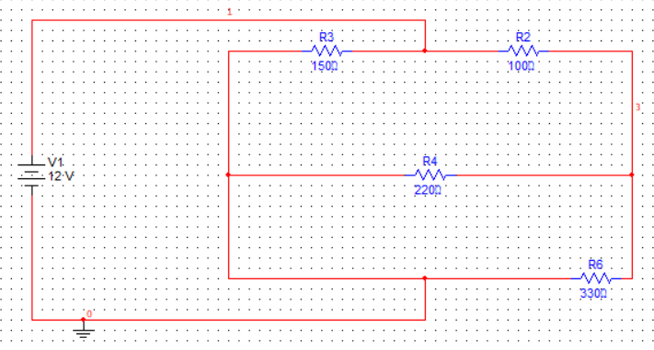

1 ) First step measurement Req in Circuit

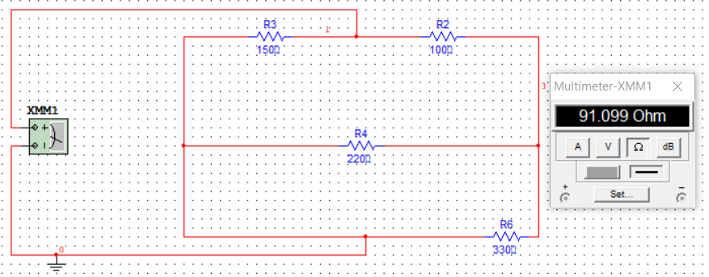

Then Req = 91.099 Ω

2 ) Second step measurement Current and Voltage

A ) Current value

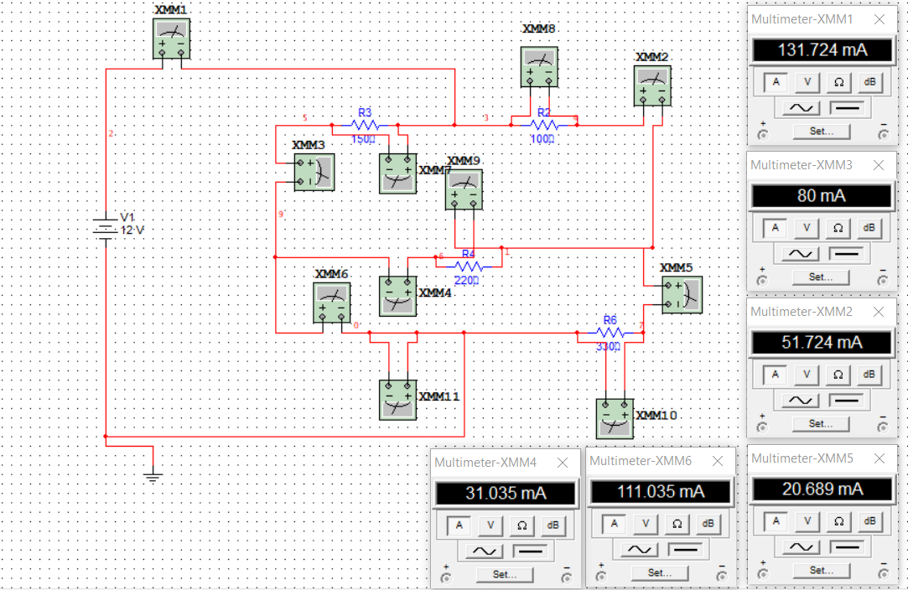

|  |  |  |  |  |  |
| --- | --- | --- | --- | --- | --- |
| IS | I2 | I3 | I4 | I5 | I6 |
| 131.724 mA | 51.724mA | 80mA | 31.035mA | 111.035mA | 20.689mA |

B ) Voltage value

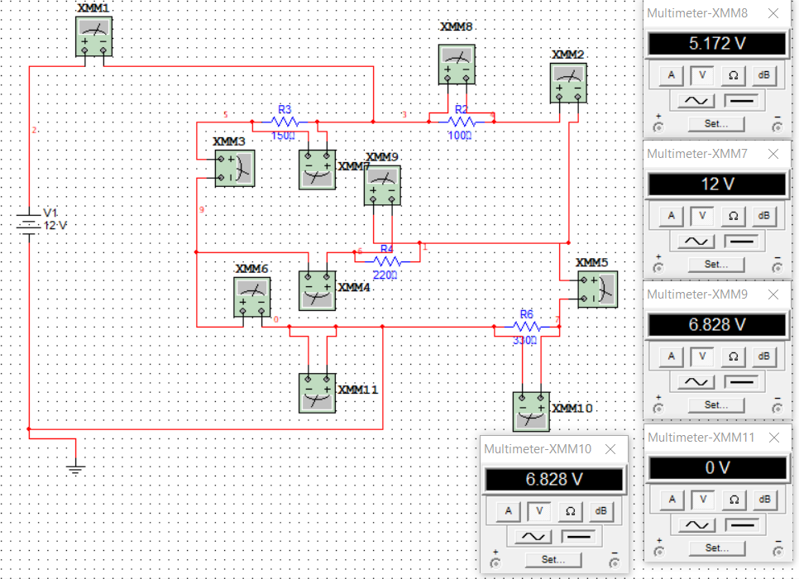

|  |  |  |  |  |
| --- | --- | --- | --- | --- |
| V2 | V3 | V4 | V5 | V6 |
| 5.172 v | 12v | 6.828v | 0 v | 6.828 v |

Question :

1. Are R4 and R6 in parallel or in series? Why? Refer to voltage current

measurements for your answer to justify ?

answer : They are in parallel

2. Are R3 and R4 in parallel or in series? Why? Justify

answer : They are in Series

3. Are Vs and R3 in parallel or in series? Why? Justify

answer : They are in Series

4. Are Vs and R6 in series or in parallel? Why? Justify

answer : They are in Series

5. Are Vs and Req. in parallel or in series? Why? Justify

answer : They are in Series

6. Is VDR applicable for applicable R3 and R4? Why? Justify your answer on the

basis of theory given in the introduction

answer : Yes , it is applicable

7. Is CDR applicable for R4 and R6? Why? Justify your answer on the basis of theory

given in the introduction.

answer : Yes , it is applicable

8. Is the parallel combination of R4 and R6 in series or in parallel with R2? Why?

Justify.

answer : They are in Series

Conclusion :

I studied the law of VDR and the law of CDR with Parallel and Series Resistor's

And I have a noticeable increase current in the branch which is located between R3 , R4 and R6 ( 111.035 mA )

current increase because branch not have resistor .